Advance Health Monitoring System  
ECG and Heart Rate Analysis for Early Detection and Diagnosis

Ashutosh Rajendra karve

Bits-ID: 2024ht01021

[2024ht01021@wilp.bits-pilani.ac.in](mailto:2024ht01021@wilp.bits-pilani.ac.in)

+91 9765541324

Pune, Maharashtra

14/09/2024

GUIDED FOR DETAILED UNDERSTANDING OF ECG AND WORKING

Dr. Prachi Pawar (BHMS)  
Reg No:(85206)   
Pune, Maharashtra

**Abstract**

This project develops an advanced health monitoring system that uses the STM32 Blue Pill microcontroller and AD8232 ECG sensor to capture comprehensive cardiovascular data. The system is designed not only to monitor heart rate but also to detect critical conditions such as heart attacks, myocardial infarction, and electrolyte imbalances through sophisticated signal processing and diagnostic algorithms implemented in Python. Data captured in real-time is analyzed to identify abnormal rhythms and potential cardiovascular issues, providing detailed health reports within minutes.

**1 Introduction**

The **Advance Health Monitoring System** is a project aimed at developing a real-time ECG monitoring solution using the STM32 Blue Pill microcontroller and AD8232 ECG sensor. The primary objective of this project is to capture ECG data from a user, transmit it via USB to a Python-based system for analysis, and visualize the ECG signal. The current version of the project is focused on raw ECG data acquisition and visualization, with plans for further development, such as AI-based analysis, in the future.

**2 System Design**

The system is designed to acquire ECG data from a human subject using a combination of hardware and software components:

**Hardware:**

* STM32 Blue Pill Microcontroller: Used for data acquisition via its analog-to-digital converter (ADC) and communication over USB (virtual COM port).
* AD8232 ECG Sensor: Measures the electrical activity of the heart and outputs analog signals, which are fed into the STM32 for processing.

**Software:**

* STM32 Firmware: The firmware reads raw ADC data from the ECG sensor connected to the STM32’s PA1 (A1) pin. The raw data (0-4095 for 12-bit ADC) is transmitted to a PC via USB.
* Python Interface: The Python code reads the raw ECG data from the STM32 and plots the real-time ECG signal. The data is visualized to observe the heart’s electrical activity over time.

**3 Hardware Integration**

**Step 1: Assembling the Hardware**

* **Components Required**:
  + STM32 Blue Pill microcontroller

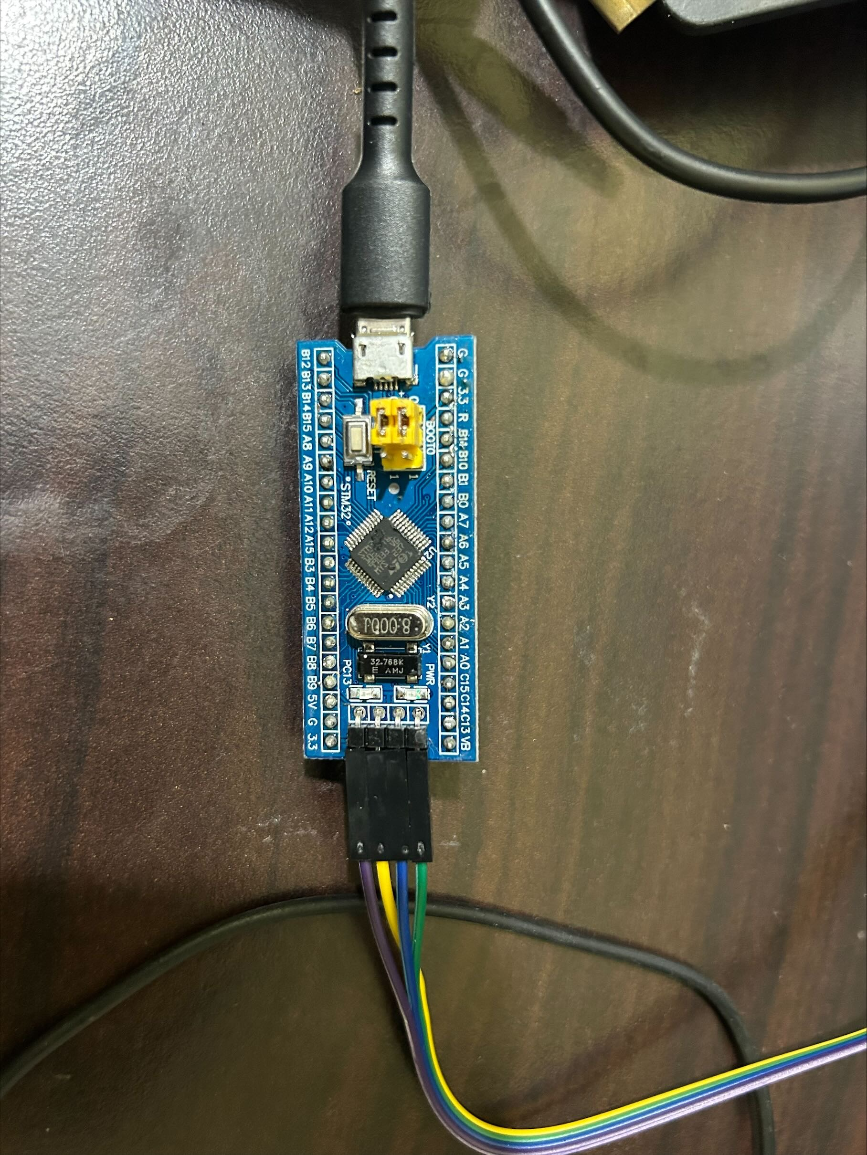  
STM32(Blue Pill) Development Board

Microcontroller:  
  
 Part : STM32F103C8T6  
 Manufacturer : ST-Microelectronics  
 Core : Arm Cortex-M3  
 Max. Clock : Speed 72MHz  
 Package : LQFP 48 pins

Internal memories:  
  
 FLASH : 64KiB  
 SRAM : 20KiB

Oscillators:  
  
 HSI : 8MHz  
 LSI : 40kHz  
 HSE : 8MHz  
 LSE : 32.768kHz

Power:  
  
 Sources : Any +3.3V pin (+3.3V)  
 Any +5V pin (+5V)  
 USB connector (+5V)

* + USB cables & ST Link V2 for Programming

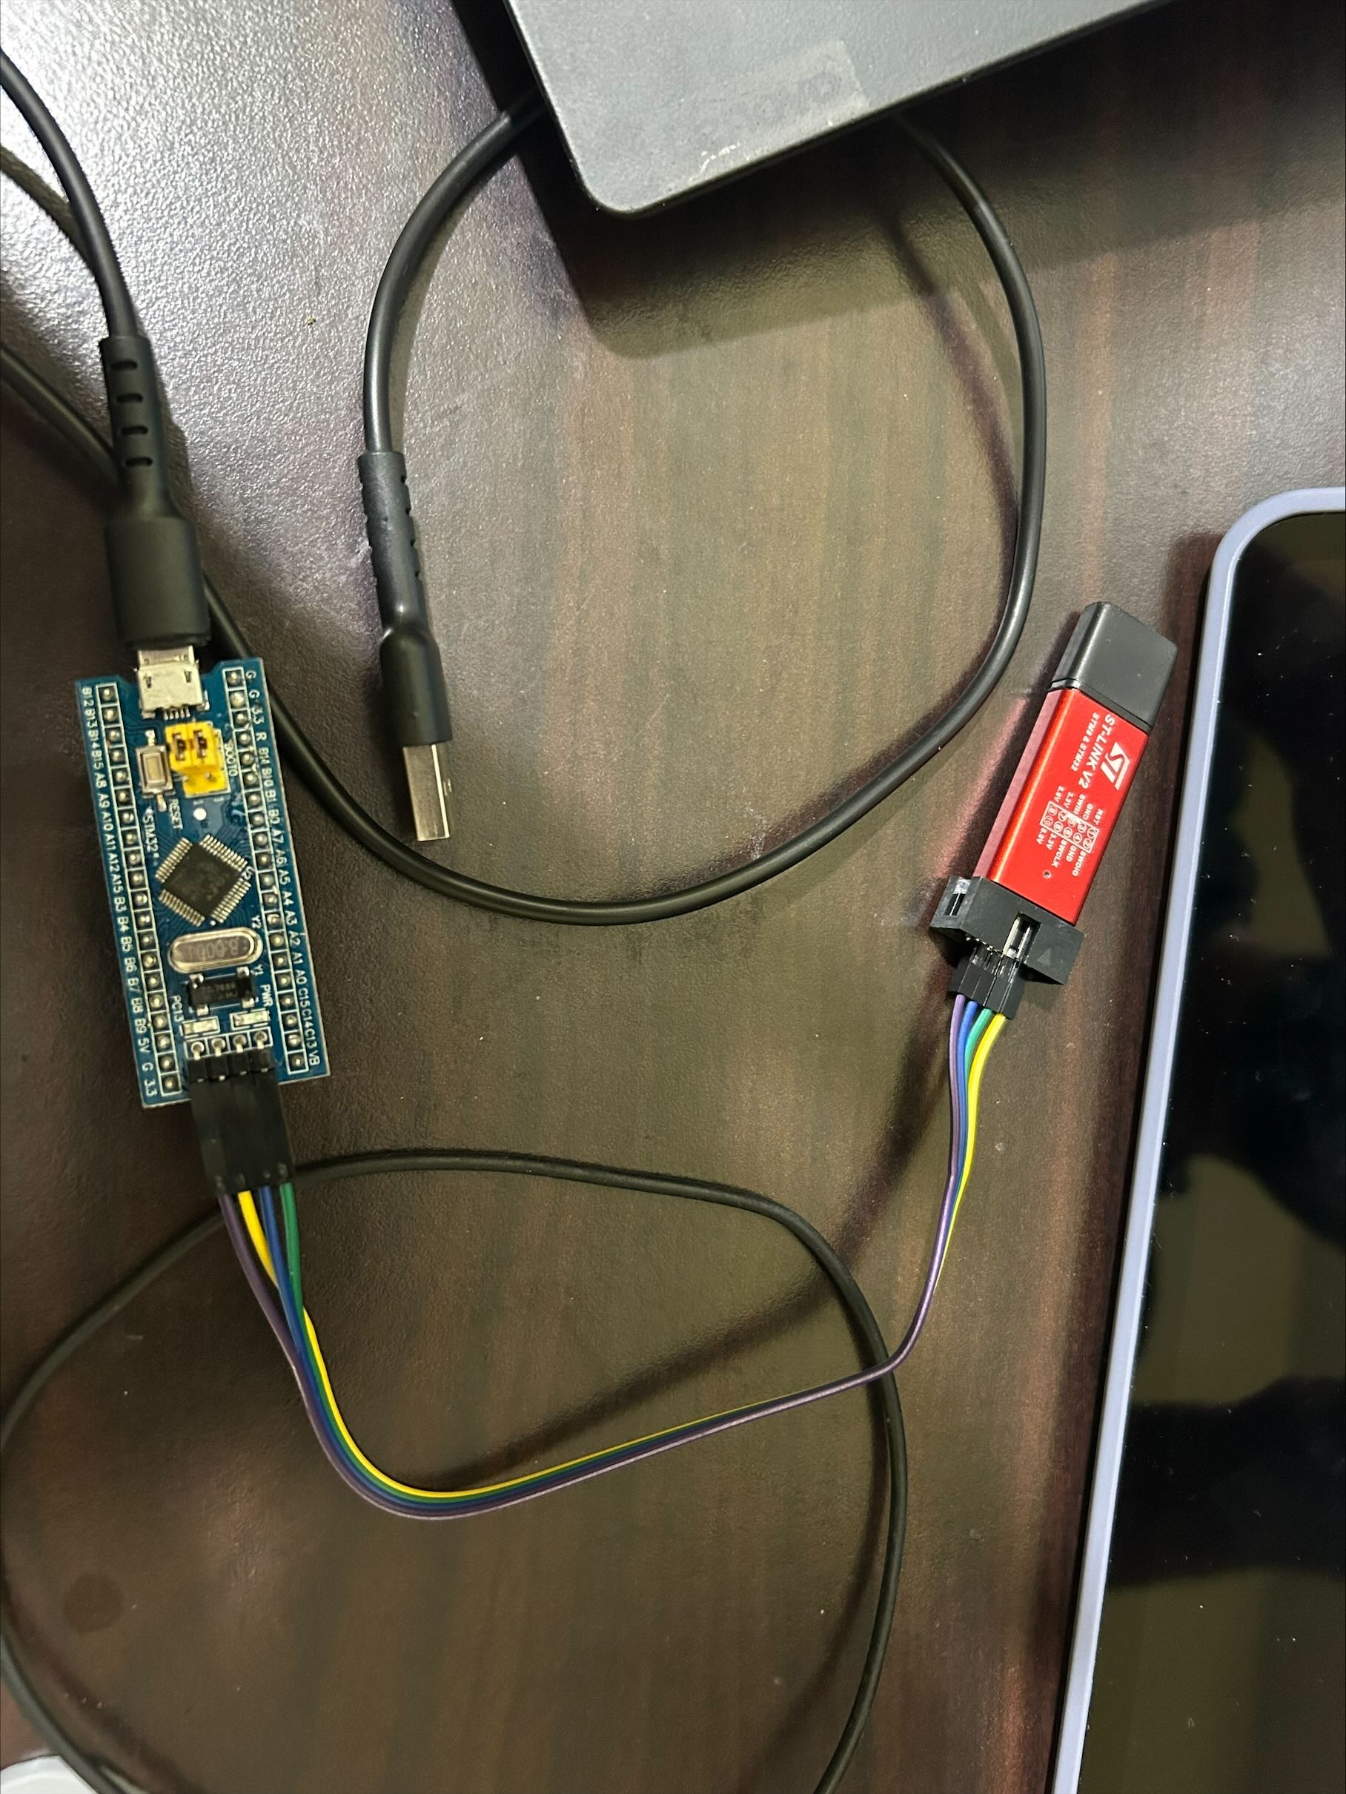

**Possible Connections**

To use a ST-Link to program a blue/black pill (BP) under external  
power, connect it like this:

ST-Link GND (even-numbered pins from 4 to 20) to BP Ground  
ST-Link SWDIO (pin 7) to BP DIO  
ST-Link SWCLK (pin 9) to BP CLK  
ST-Link VAPP (pins 1 or 2) to BP 3V3

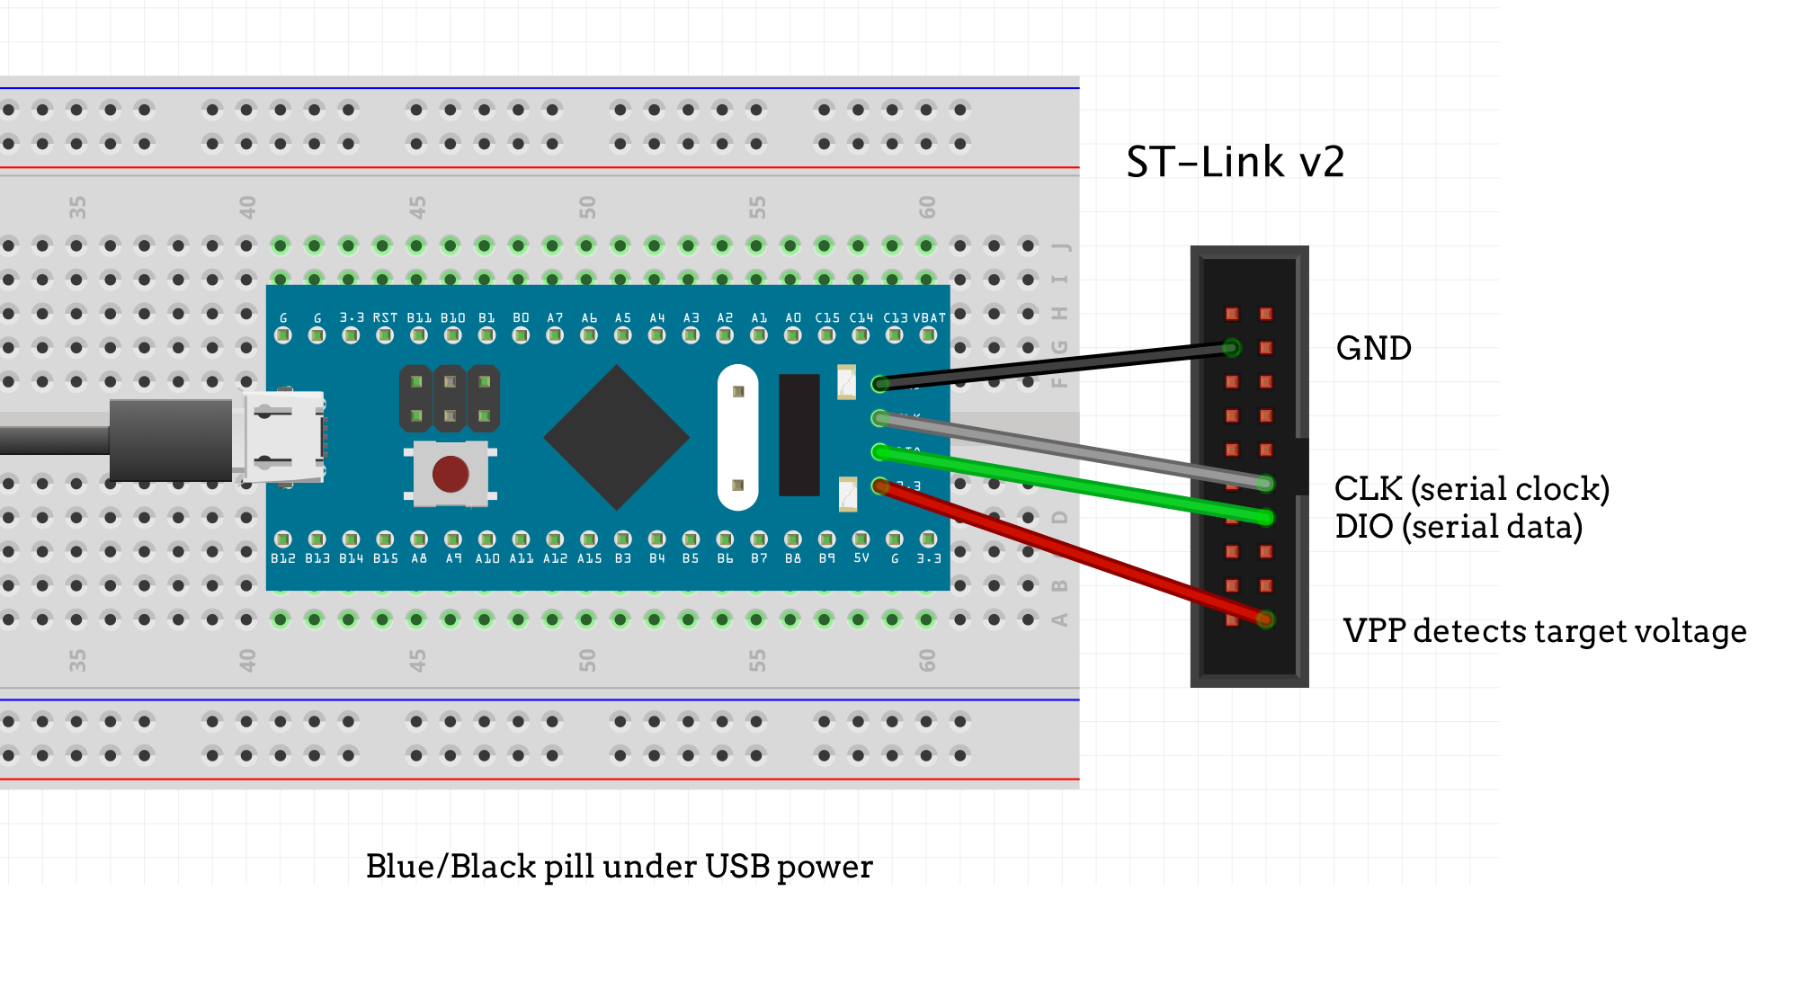

* + AD8232 ECG Sensor

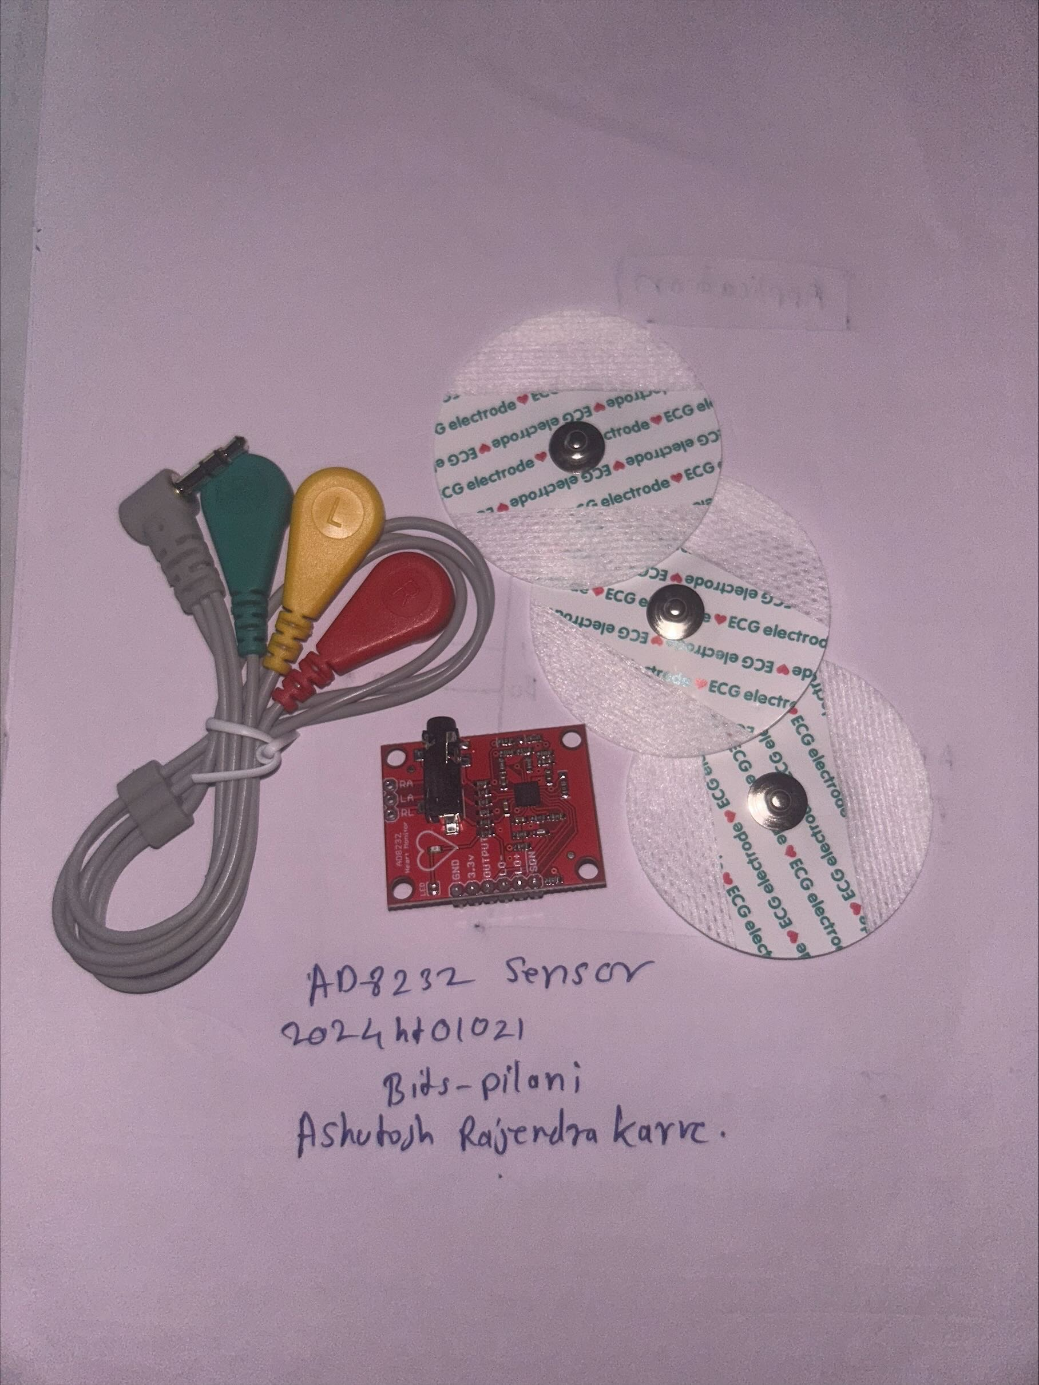

The **AD8232 ECG sensor** is designed for measuring heart activity by capturing, amplifying, and filtering ECG signals. It removes noise and interference, providing a clean analog signal for further processing.

**Key Features:**

* **Low Power**: Ideal for portable health monitoring.
* **Noise Filtering**: Removes motion artifacts and electrical interference for cleaner signals.
* **Electrode Inputs**: Requires three electrodes (right arm, left arm, right leg) for accurate readings.
* **Analog Output**: Provides analog ECG signals to the STM32's ADC for digitization.

In this project, the sensor’s output is connected to **PA1 (A1)** on the STM32, which digitizes and transmits the ECG data over USB for real-time analysis and visualization.

* + Heartbeat Pulse Sensor (For Future scope)

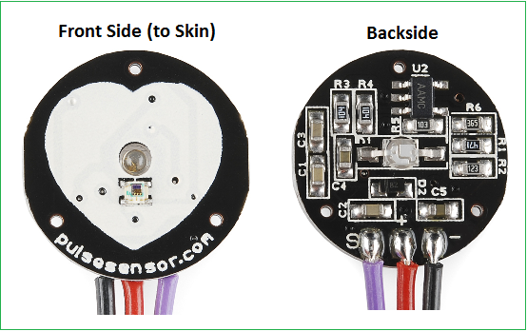  
The **Heartbeat Pulse Sensor** is designed to measure heart rate by detecting the blood flow through the skin using photoplethysmography (PPG). It provides an easy way to monitor pulse activity by converting the changes in light absorption, caused by blood flow, into an electrical signal.

* + Connecting wires
* **Procedure:**
  + **Power Connections**:
    - Connect the 3.3V and GND pins of the STM32 to the respective pins on the AD8232 and Heart Pulse Sensor.
  + **Signal Connections**:
    - Connect the OUTPUT of the AD8232 to PA0 on STM32 for ECG data capture.
    - Connect the OUTPUT of the Heart Pulse Sensor to PA1 on STM32 for heart rate measurement.
  + **USB Configuration**:
    - Ensure PA11 (USB_DM) and PA12 (USB_DP) are connected for USB functionality.
  + **Configuring Leads-Off Detection:**
    - Use PB0 and PB1 on STM32 to connect to LO- and LO+ on the AD8232 for detecting if the leads are properly attached.

**Step 2: STM32 CUBE MX Pin Configuration**

* **USB Configuration on STM32 Blue pill**I will use the STM32F103C8 controller in the USB DEVICE mode, and the Communication Device class (Virtual Com Port). The setup for the same is shown below screen shot

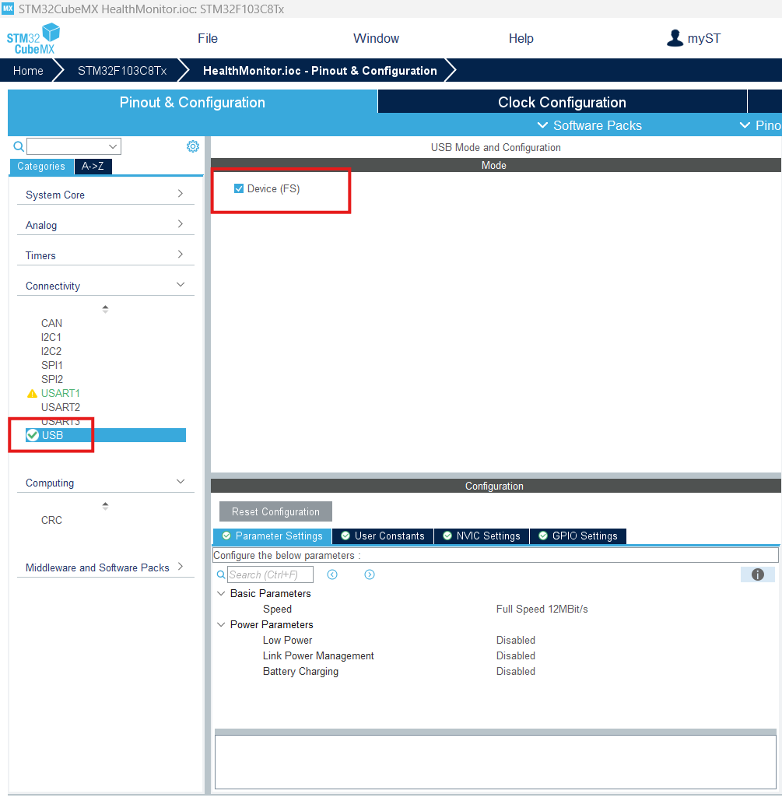First, I am selecting the USB in DEVICE only MODE, as shown above

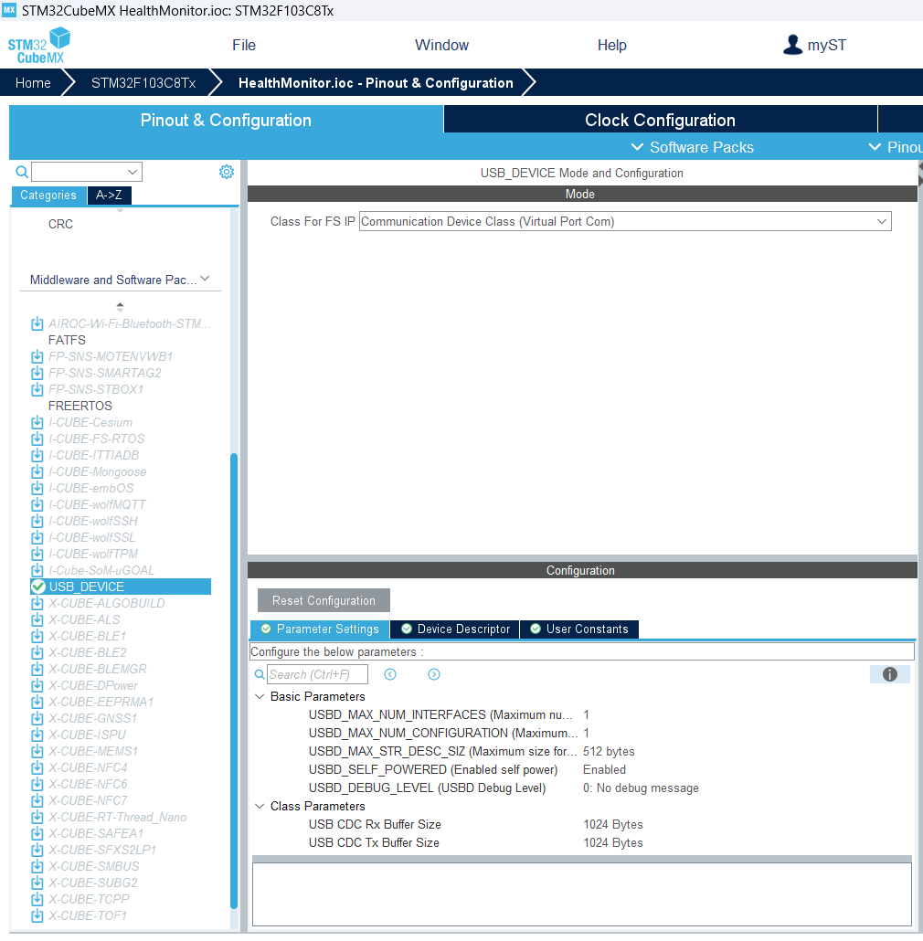  
in the USB Device, Select the class as Communication Device Class (Virtual Port Com)

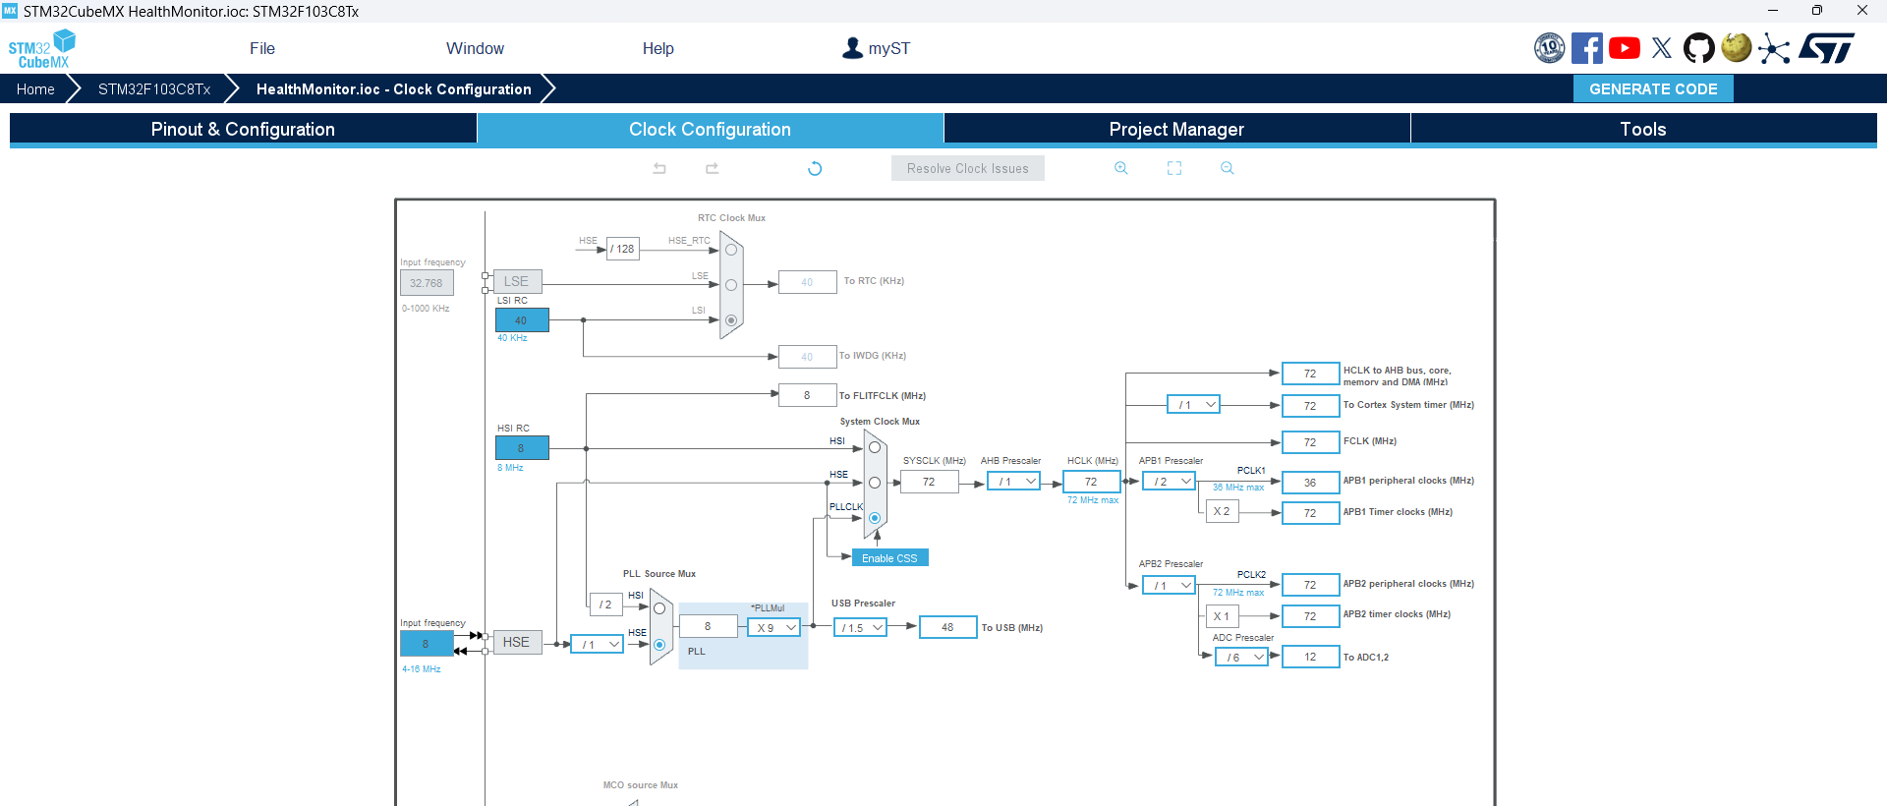

Finally, the clock is set to maximum here. As you can see above, the USB clock is automatically adjusted to 48 MHz

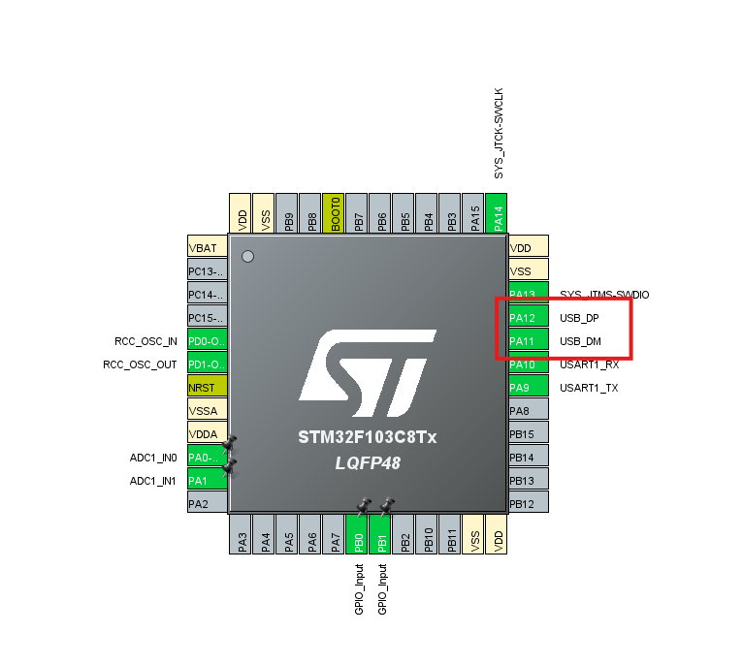  
Ensure PA11 (USB_DM) and PA12(USB_DP) are connected for USB functionality

* **Sensor connection and configuration:**

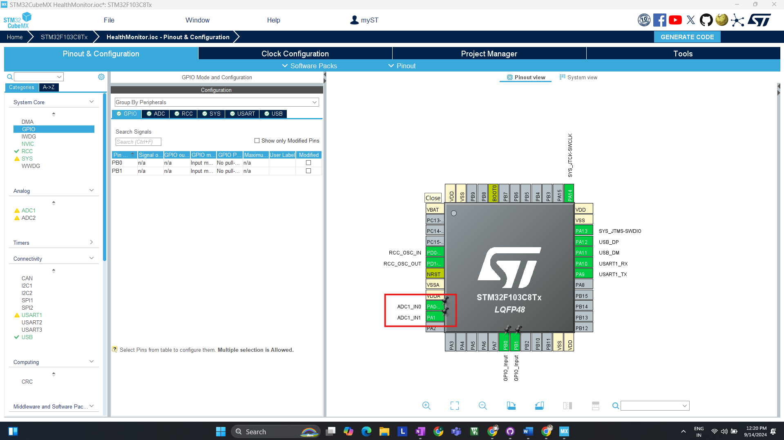

ADC Configuration is done for AD8283 & Heart Pulse detector sensor, AD8232 to **PA0** on STM32 for ECG data capture, Heart Pulse Sensor to **PA1** on STM32 for heart rate measurement.

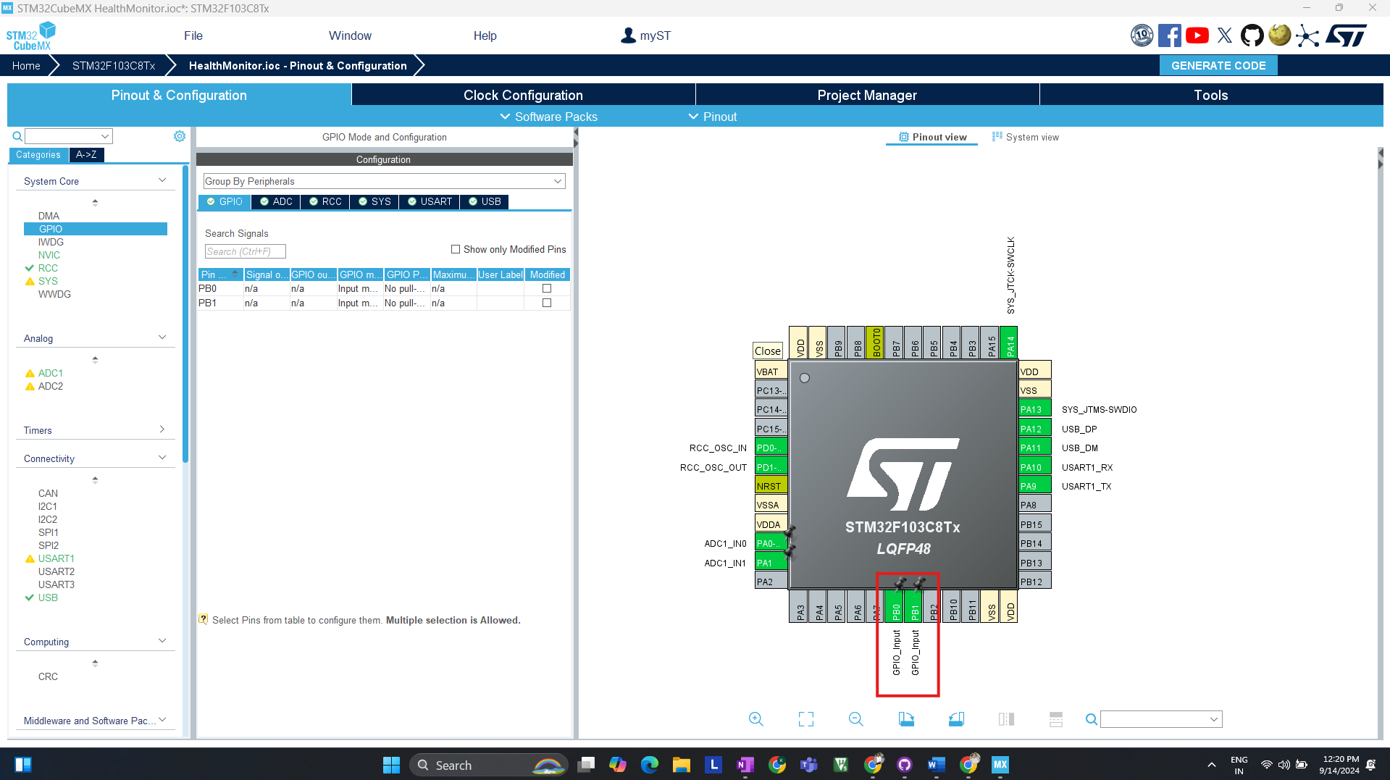Use PB0 and PB1 on STM32 to connect to LO- and LO+ on the AD8232 for detecting if leads are properly attached.

**4 Software Integration (Firmware Development & Testing STM32)**

**Step 1: Environment Setup**

* **Tools Required:**
  + Keil V5 for programming and debugging.
* **Procedure:**
  + Install Keil V5 and configure the project for STM32F103C8Tx.
  + Set up project directories and necessary libraries (HAL, USB CDC).

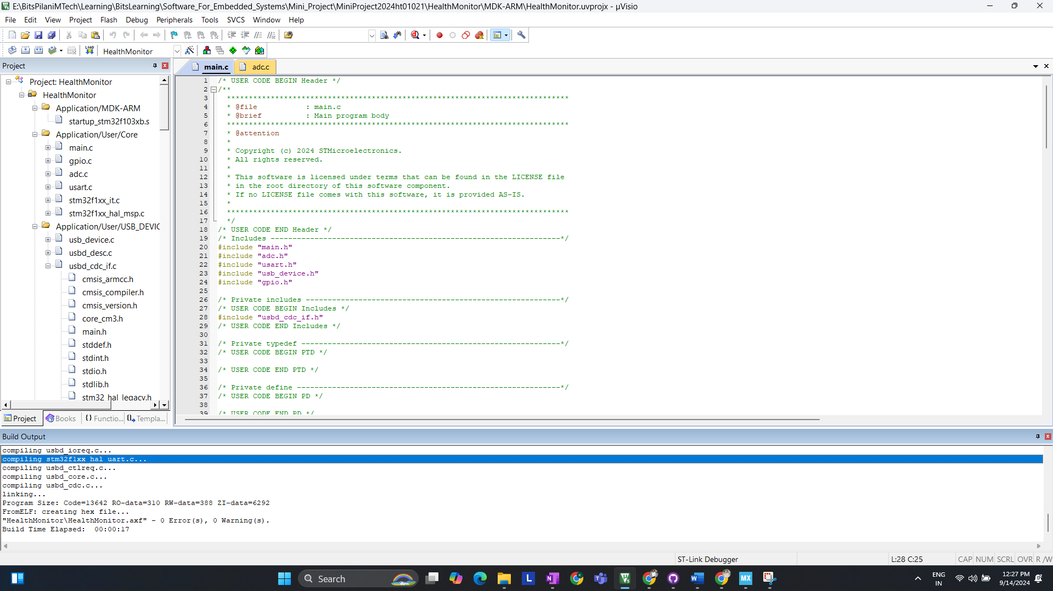  
  
Screen shot of error less code after generating code from STM32 Cube MX.

**Step 2: Coding (Initial Basic Setup & Testing)**

* 1. **USB Communication Setup**:  
     Implement USB CDC for data transmission to Ubuntu.

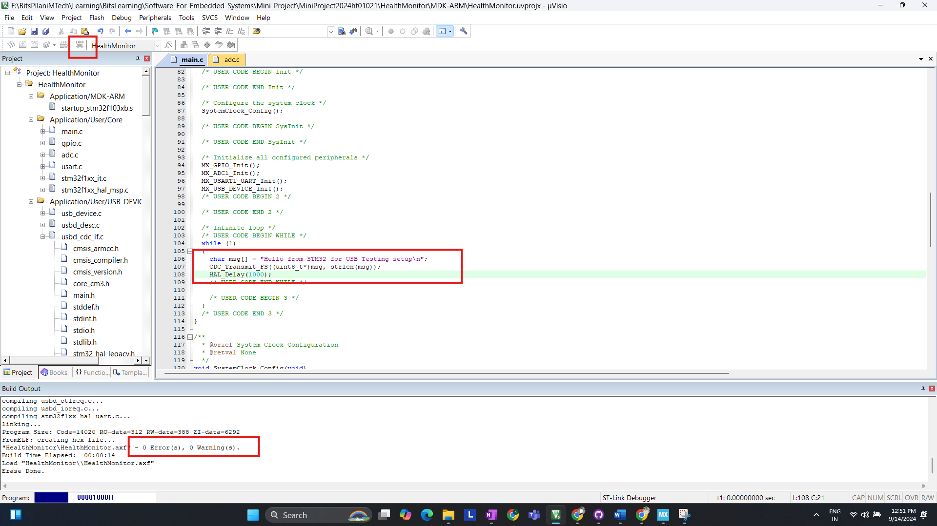  
In above screenshot I have compiled and flash code for USB CDC.  
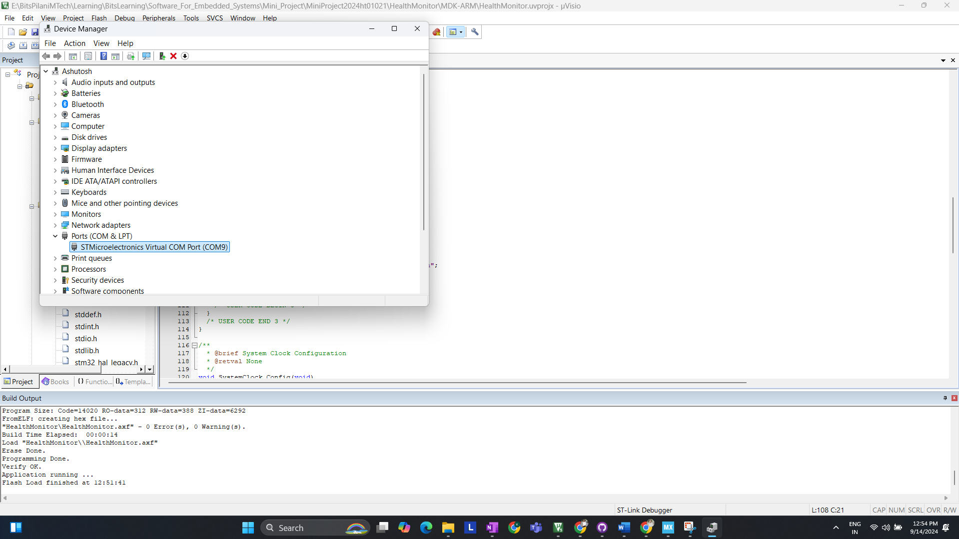  
We can detect COM Port (COM9) for Our device (STM32 Blue Pill)

* 1. **Checking with putty:**

Configuring Serial to COM9 and setting baud rate to 9600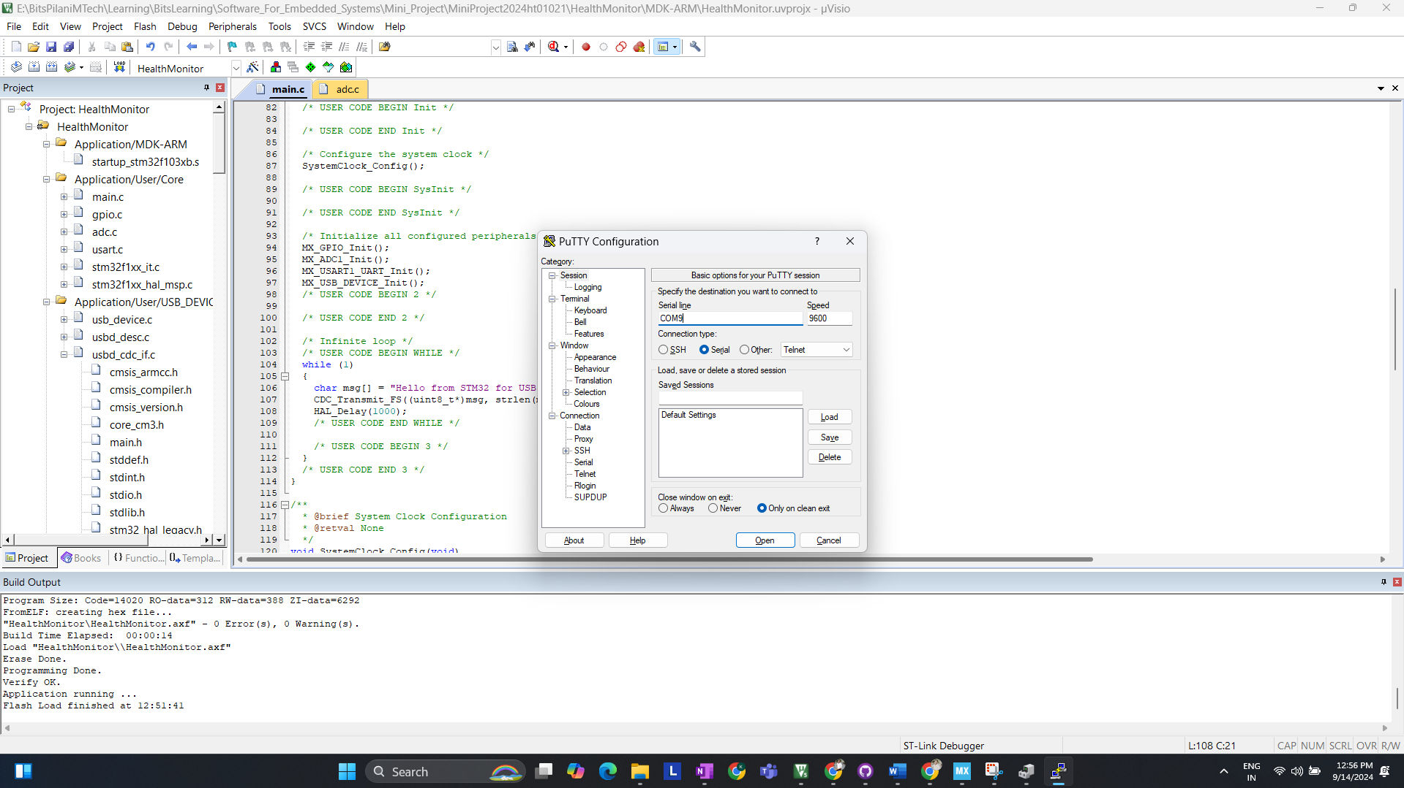  
Checking Serial Terminal We are receiving the DATA  
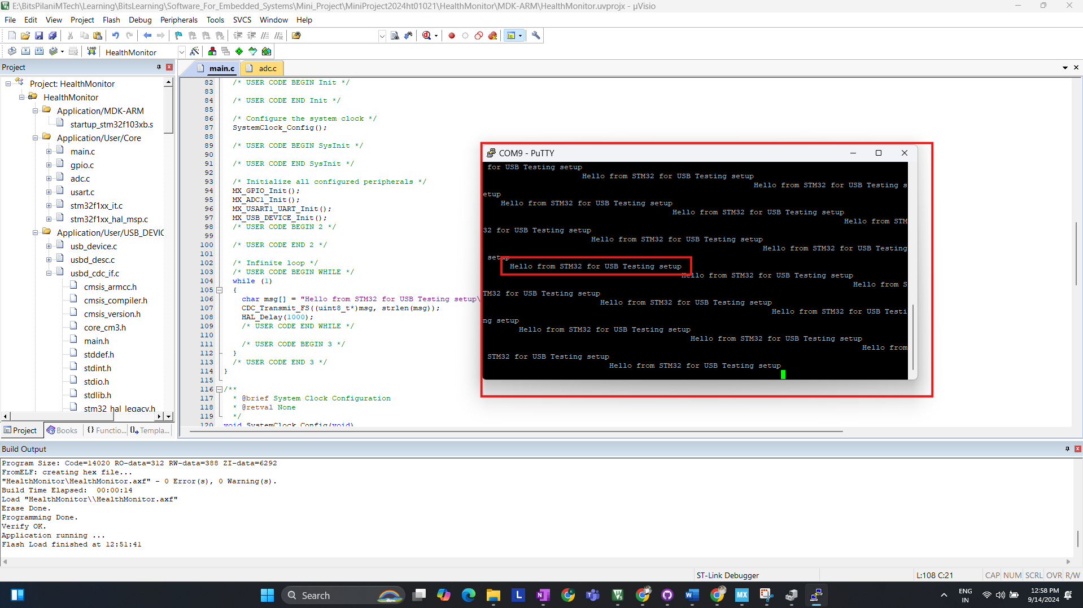

* 1. **ADC Configuration**:

The ADC is configured to read analog values from the ECG sensor connected to PA0 and the Heart Pulse sensor connected to PA1. The following code snippet demonstrates how to configure the ADC

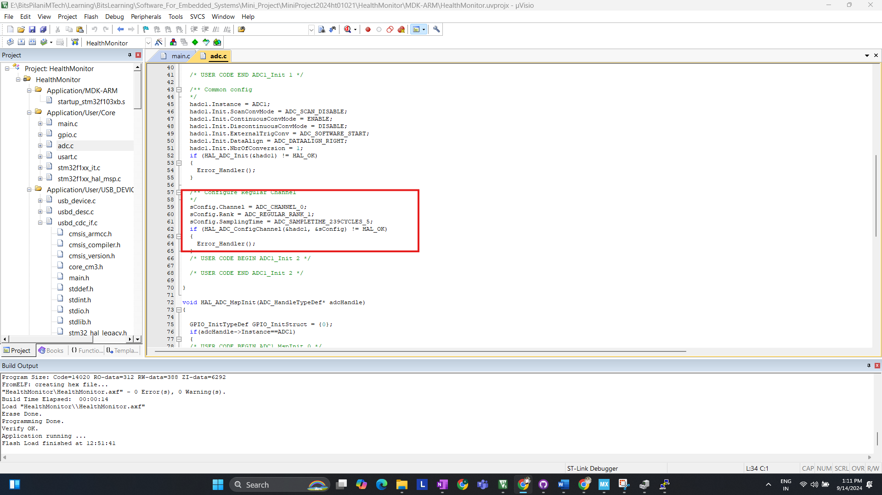

* 1. **Testing and debugging on Ubuntu**

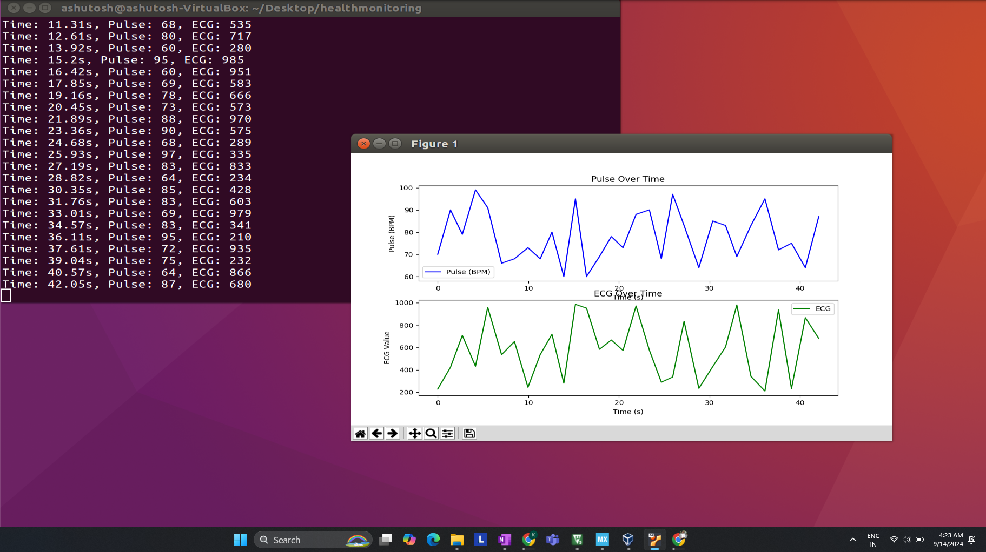  
Initial Fetching of RAW DATA for ECG and PULSE ON UBUNTU

**Step 3: Software Development on Ubuntu for Data Processing**

After completing the firmware development and testing the STM32's ability to transmit data via USB, the next step involves setting up the Python-based system on Ubuntu.

**Step 1: Setting Up the Python Environment**

**Tools Required:**

* Python 3.6 or higher
* Libraries:
  + **pyserial** for USB communication
  + **matplotlib** for visualizing ECG and pulse data
  + **numpy** for data handling and signal processing
  + **scipy** (optional) for more advanced signal processing and peak detection

**Step 2: Writing Python Code to Read Data from STM32**

The Python script will connect to the STM32 via the virtual COM port over USB, read the incoming data, and then process it. Below is a simple script to start reading the data. (Basic program to check connection with STM32 USB CDC)

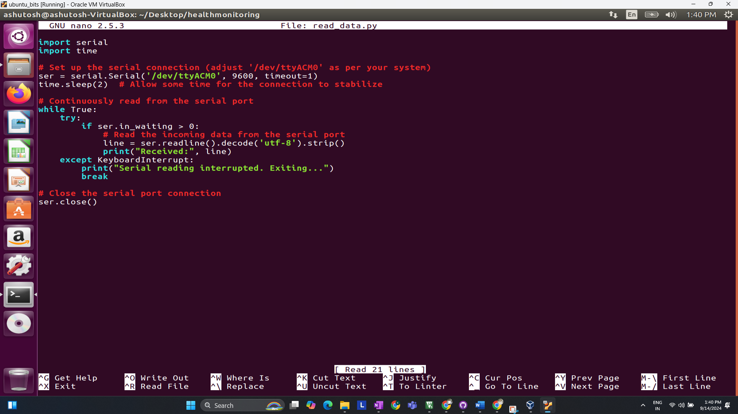

**Explanation**:

* The serial.Serial() function opens the USB serial port.
* The script reads incoming data from the STM32, which is sent every second, and prints it to the console.

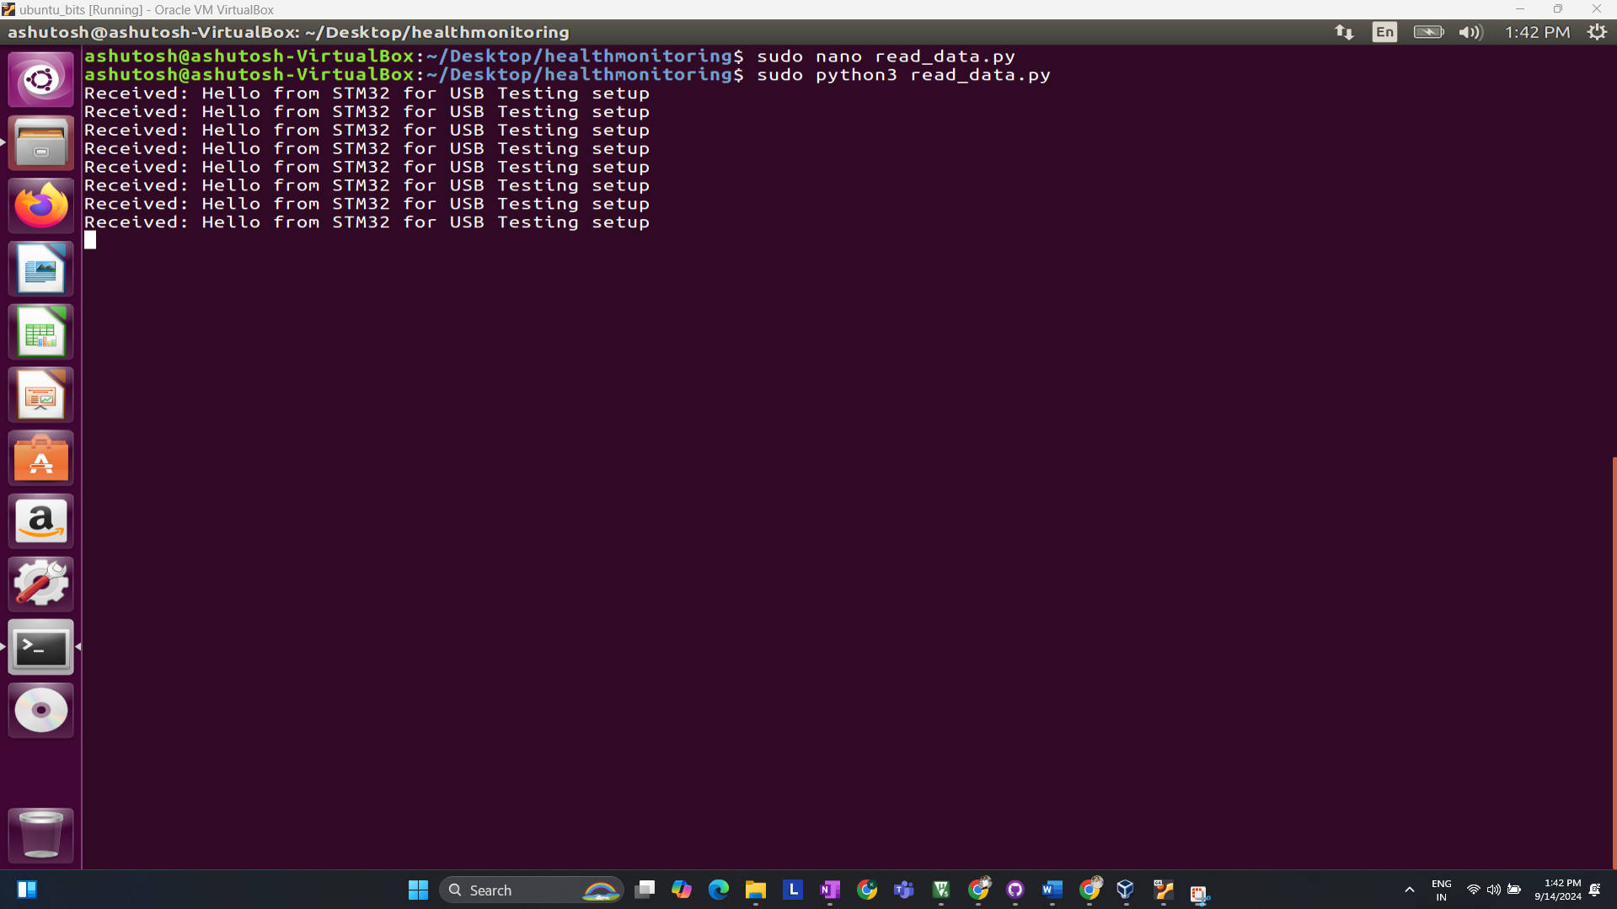

**Step 3: Visualizing the Data (Basic Visualization) (Testing)**

Once the data is received from STM32, it is important to visualize it. Using matplotlib, you can plot the ECG and heart pulse data in real-time.

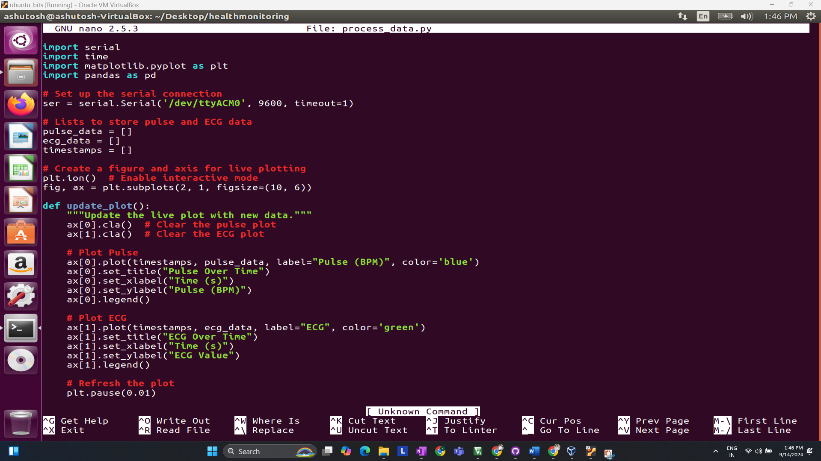

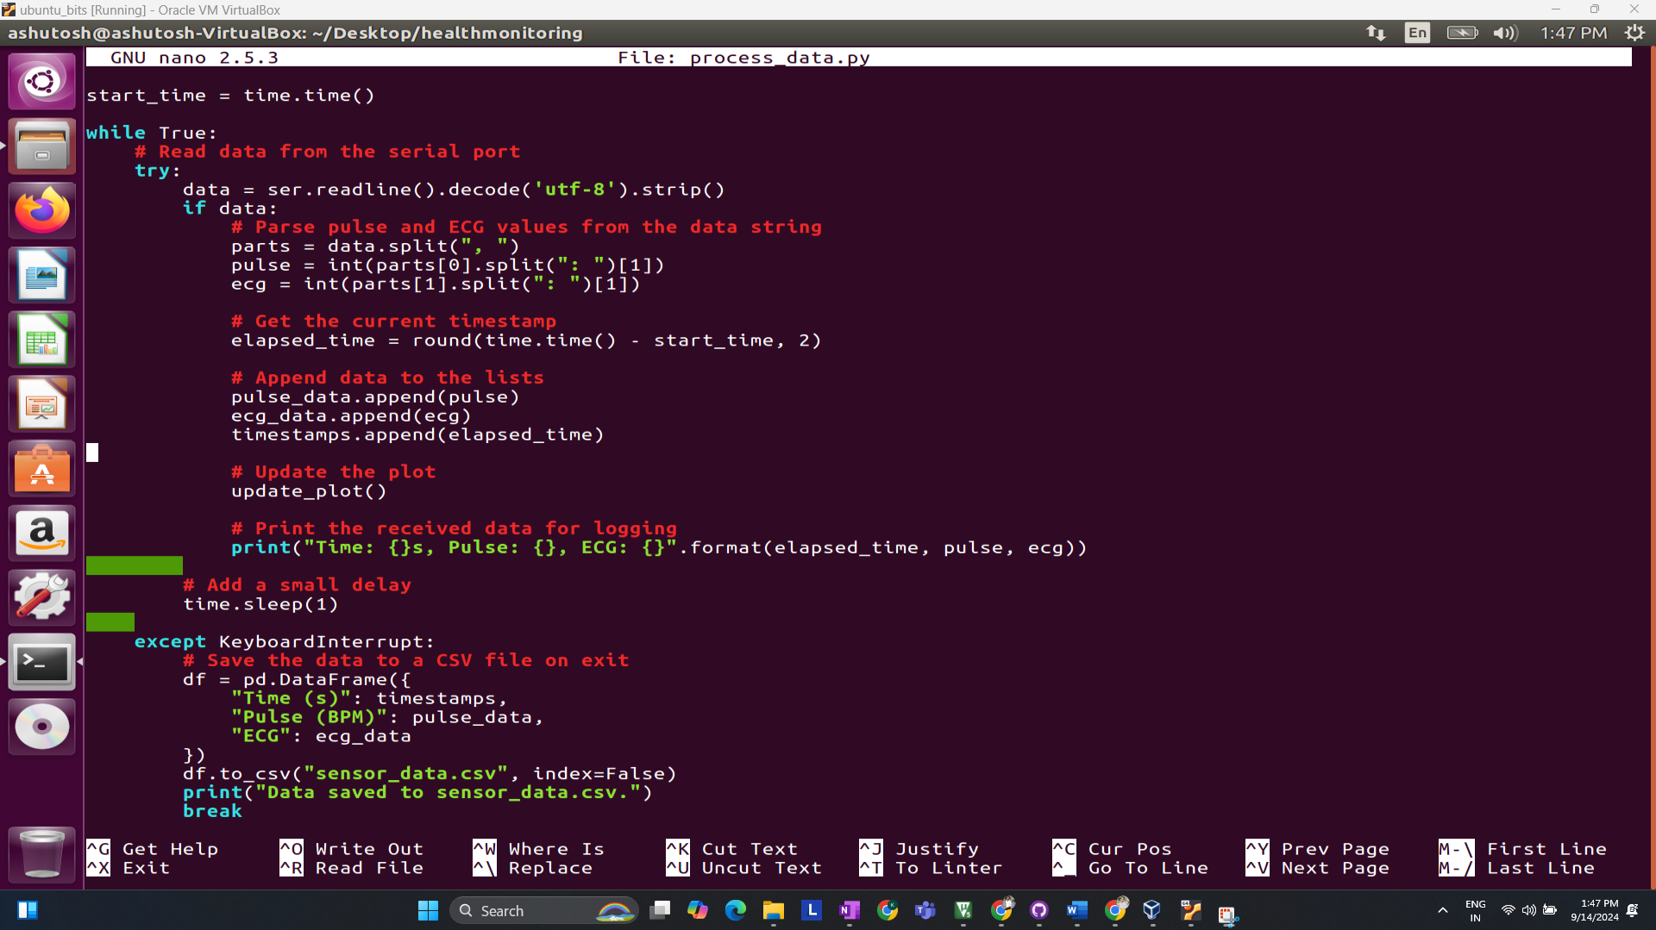

**Result:**

Real-time ECG Plot Testing…

Once the raw data is captured, you can move on to basic data processing and visualization to analyze ECG signals and detect abnormalities.

**5 Setting up actual sensor (ECG Sensor)**

**Pin-Configuration Block Diagram of STM32 + AD8232   
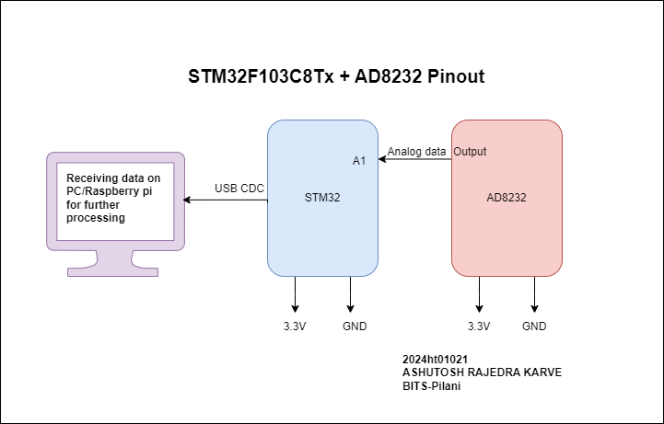  
Code//**

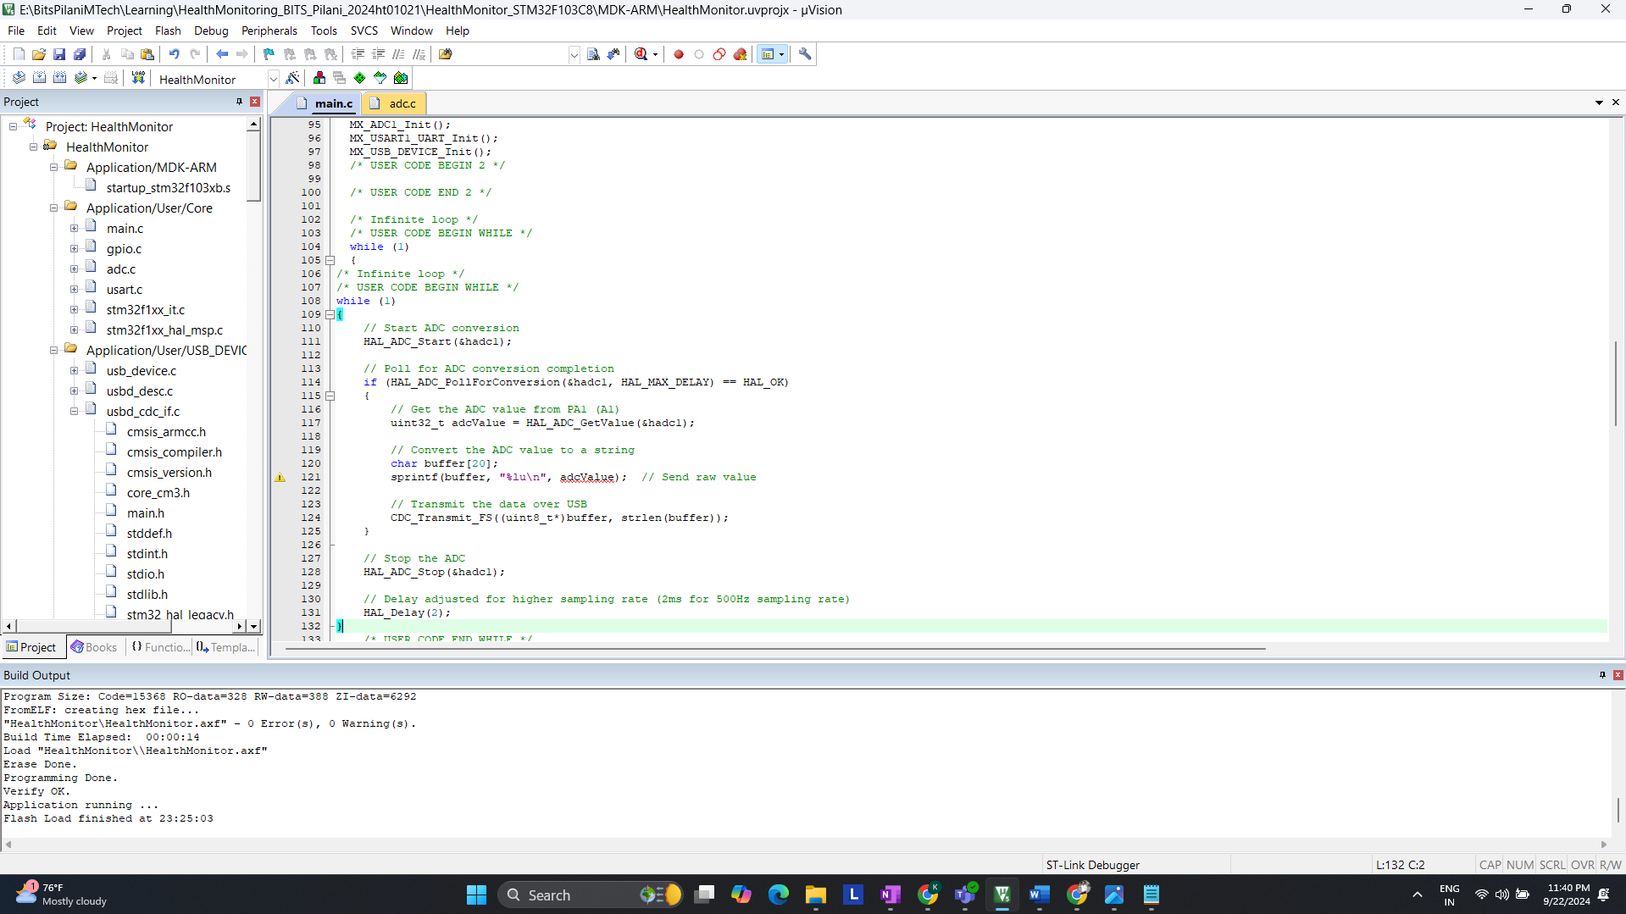

**Actual Hardware setup**

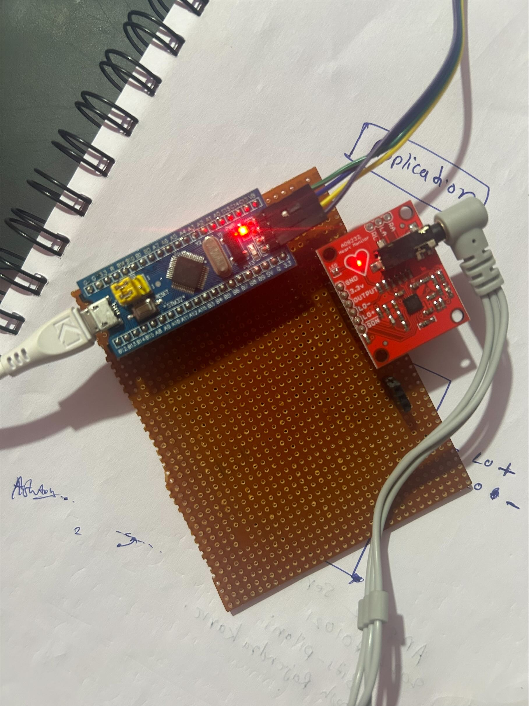

**ECG Sensor Placement on Body**

It is recommended to snap the sensor pads on the leads before sticking to the body, the closer to the heart, the better the measurement would be. The cables are color-coded to help you identify a proper placement.

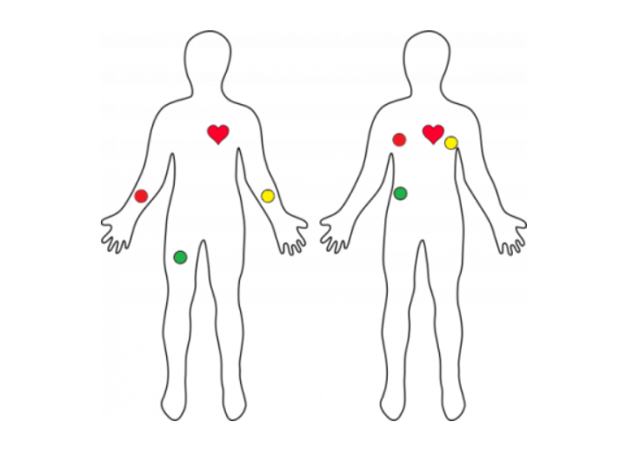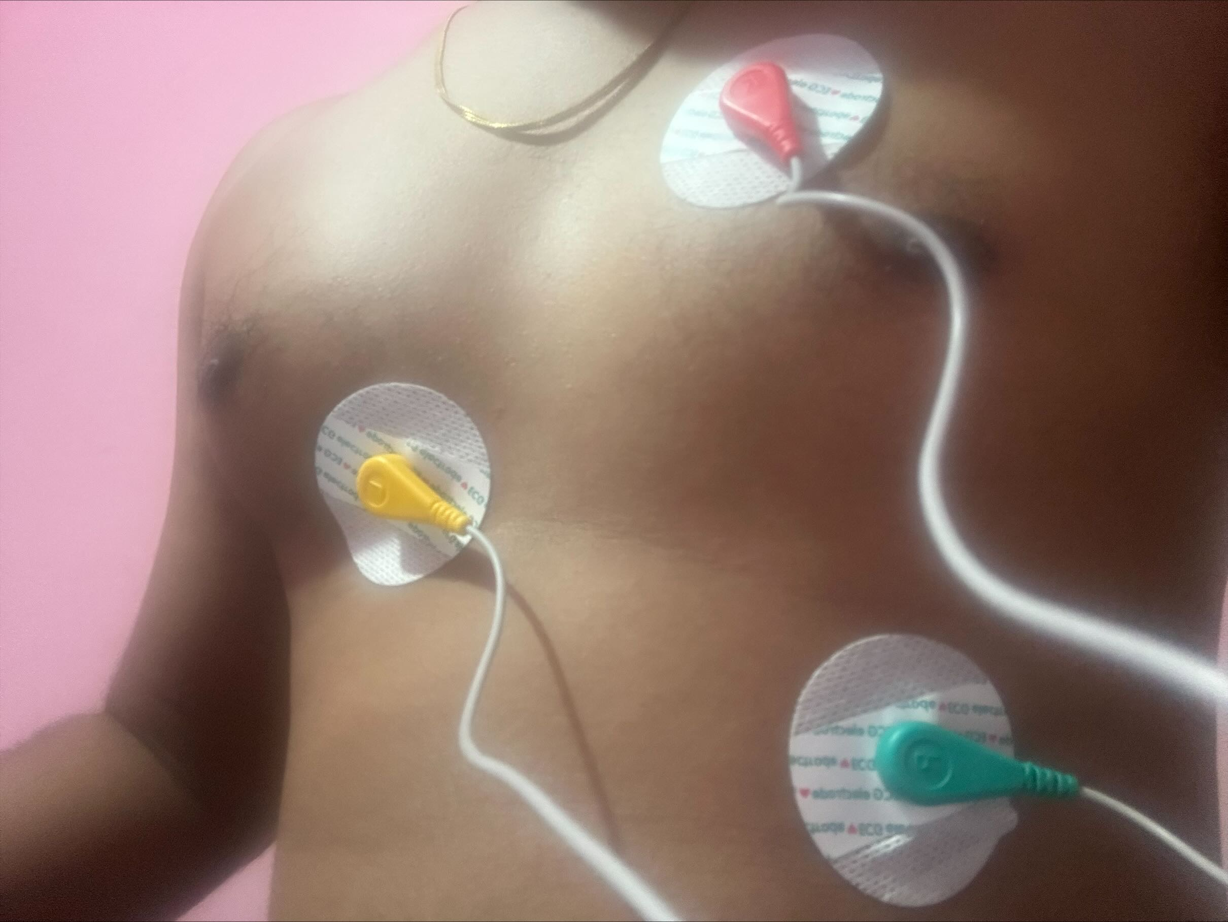

**Before moving Ahead Let’s understand what is ECG?**

ECG is the abbreviated term for an electrocardiogram. It is used to record the electrical activity of the heart from different angles to both identify and locate pathology. Electrodes are placed on different parts of a patient’s limbs and chest to record the electrical activity.

**Parts of the ECG explained**

* **P waves**

**P waves** represent **atrial depolarization**  
In healthy individuals, there should be a**P wave** preceding each **QRS** complex.

* **PR interval**

The **PR interval**begins at the**start of the** **P wave** and ends at **the beginning** of the **Q wave**.  
It **represents** the **time**for electrical activity to move**between** **the** **atria and the ventricles**.

* **QRS complex**

The **QRS complex** represents the **depolarisation of the ventricles**.  
It appears as three closely related waves on the ECG (the Q, R and S wave).

* **ST segment**

The **ST segment starts** at the **end** of the **S wave**and **ends** at the **beginning** of the**T wave**.

The **ST segment** is an isoelectric line representing the time **between** **depolarisation** and **repolarisation** of the **ventricles** (i.e. ventricular contraction).

* **T wave**

The **T wave**represents **ventricular repolarisation**.   
It appears as a small wave **after** the **QRS complex**.

* **RR interval**

The **RR interval begins** at the **peak of one R wave** & ends at the **peak of the next R wave**.  
It**represents** the **time between two QRS complexes**.

* **QT interval**

The **QT interval** begins at the start of the**QRS complex** & finishes at the end of the **T wave**.  
It **represents** the time taken for the **ventricles** to **depolarise** and then **repolarise**.

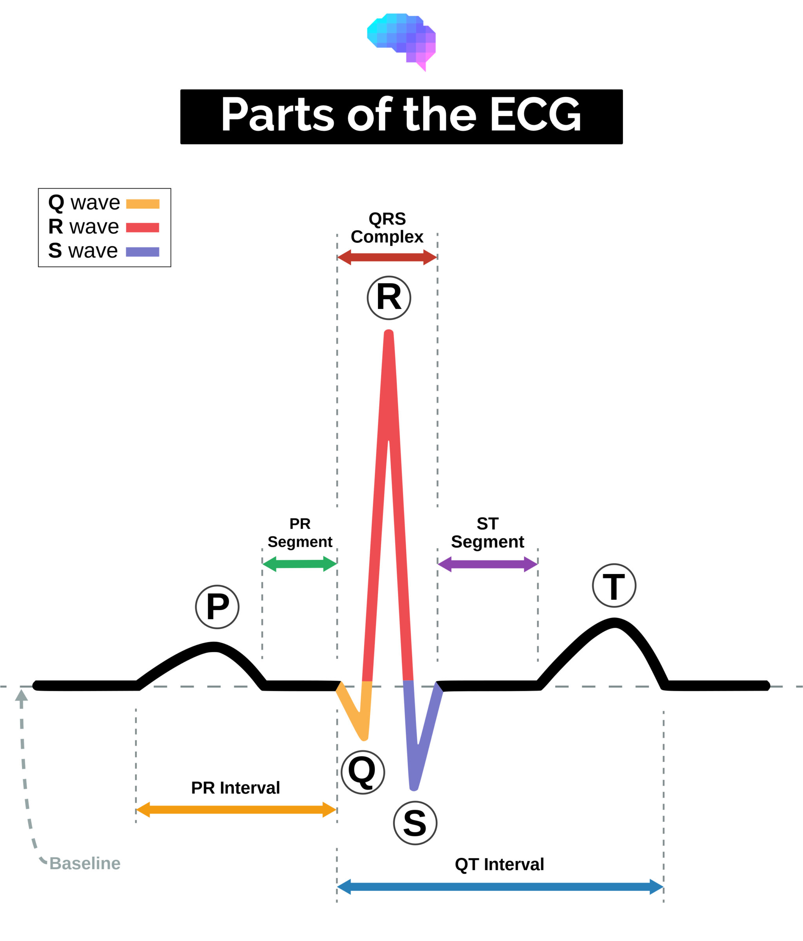

**Raw data which I am receiving on putty**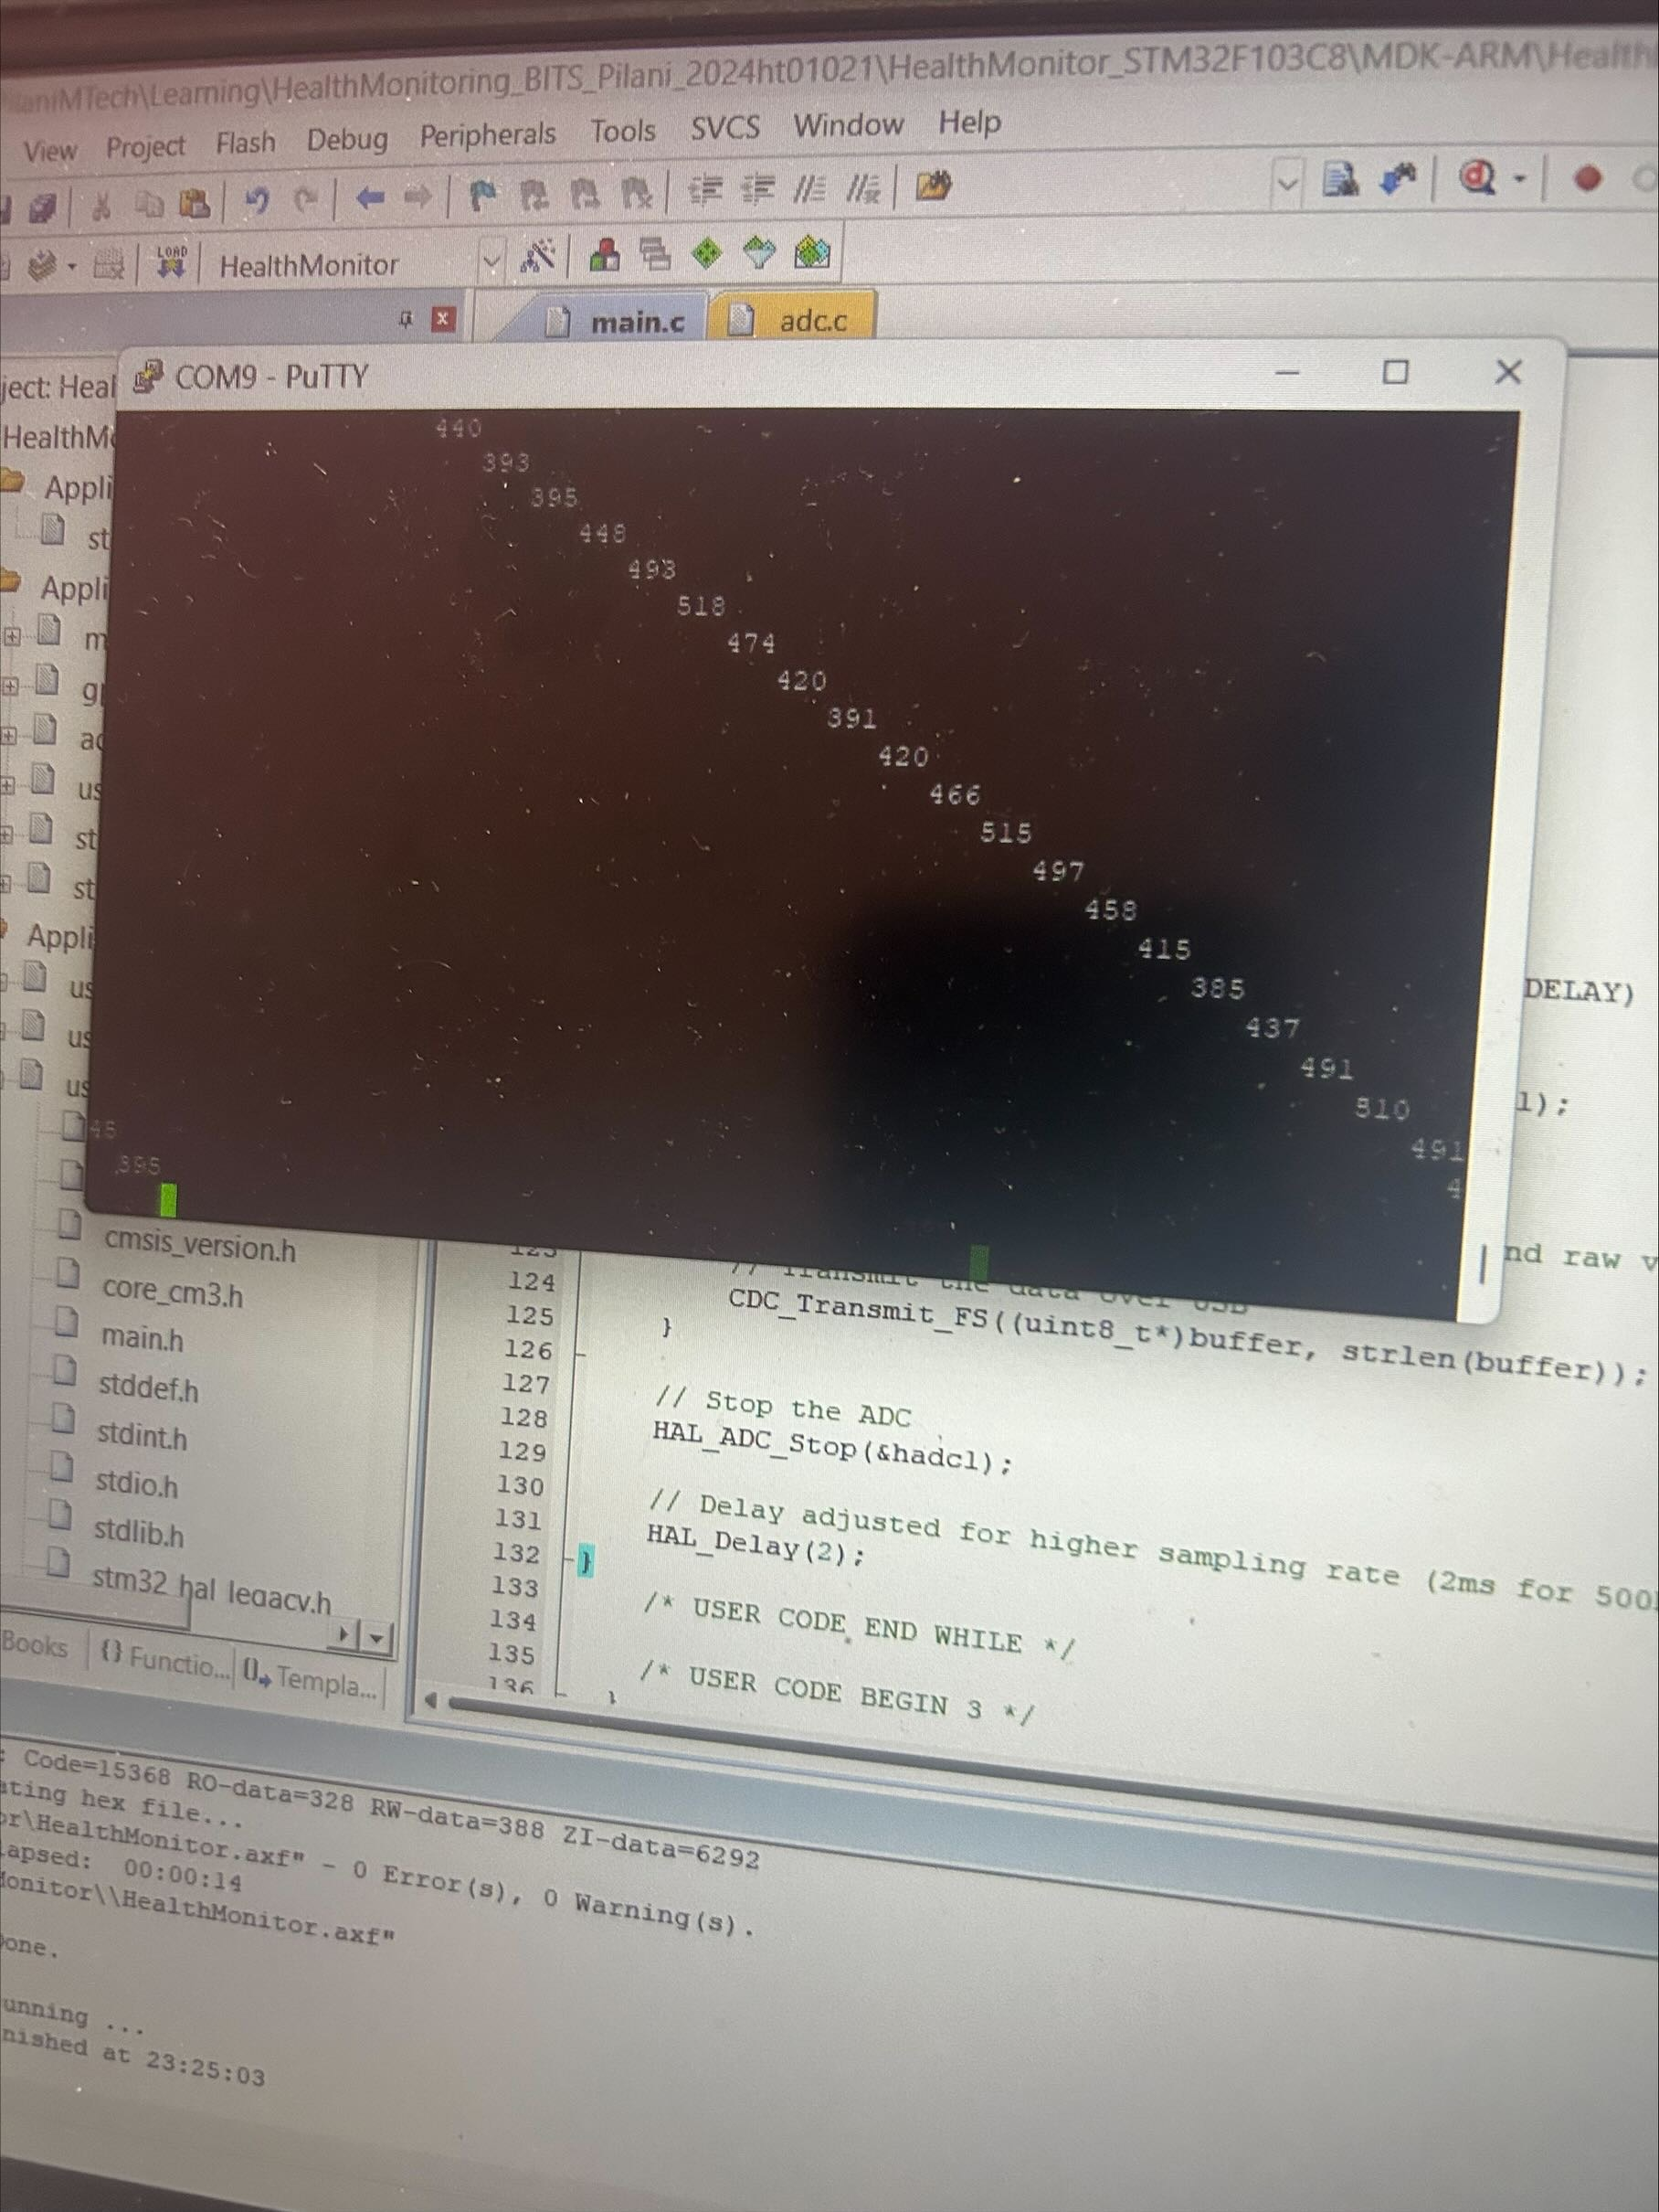

**Observations from Putty Display of ECG Data**

**Interpreting the Data:**

* Fluctuations in the range of 390–530: The readings captured in the Putty terminal indicate fluctuations between 390 and 530. These fluctuations represent various components of the ECG signal, primarily depicting the heart's electrical activity.
* QRS Complex: Values near the higher end of this range, particularly those approaching 530, are likely associated with the QRS complex, indicating ventricular contraction. This is the most prominent and critical part of an ECG trace.
* P-Wave and T-Wave: Lower values in this range, closer to 390, could potentially represent the P-wave or T-wave, which are less pronounced than the QRS complex and signify atrial depolarization and ventricular repolarization, respectively.

Periodic Patterns: The data appears to be periodically fluctuating, consistent with the expected rhythmic pattern of a normal ECG, indicating the regular beating of the heart. This rhythmic pattern is essential for analyzing cardiac function and identifying potential abnormalities.

Running Python Program for further processing.

Python Code>>  
